

Infinity
CDI ECU Control Software

User Manual

V1.13

Racetech Developments Ltd
Unit 8
York Farm Business Centre
Watling Street
Towcester
Northants NN12 8EU
England

Tel: +44 (0)1327 831100
E-mail: info@racetechdev.co.uk
Web site: www.racetechdev.co.uk

Contents.

Page Number: Title:

- System requirements.
Software installation.
Running the program.

- Opening a file from disk.
Connecting to the ECU.

- Controlling the ECU.

- Ignition map.
Cylinder 2 ignition trim.
Load sites.
Speed sites.
Water temperature compensation.

- Power valve map.
Data tracker.
Comments.

- Parameters.
System Requirements.

1GHz PC running Windows XP/Vista/7.
PC must have either a physical RS-232 serial port or a USB serial adapter installed.
PC needs to have Microsoft .NET V3.5 and Windows Installer V3.1 installed before running the SETUP program from the CD.

Software Installation.

Insert your Infinity CD into the CD/DVD drive. Double-click on the My Computer icon and then double click on the icon relating to the CD/DVD drive. There should be a program called SETUP listed in the contents of the Infinity CD. Double-click on SETUP. The installation program will begin. Follow the on screen instructions until the setup is complete.

The installation program will install link icons to the Racetech Developments sub-folder under the Programs folder from the Start menu.

Running the Program.

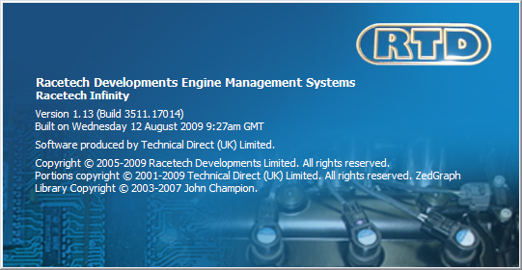
When the program begins you will see the main title splash screen.

As Infinity is a powerful tool it is capable of damaging engines if improperly used so only use it if you are authorised to do so.

If you decide to continue with the program the main screen will be displayed. At this point you have two choices: To connect to an ECU and fetch the map data from it into the pc memory or to load a set of map data from file to view before sending to an ECU upon connection.
Opening a file from disk.
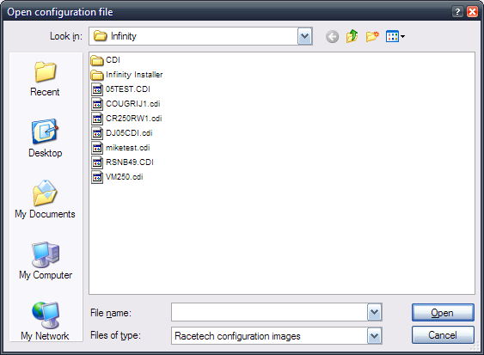
When you click on the Open icon, you will be shown a window containing available map files to load into pc memory.

If no files are listed, this may be the first time you have used Infinity and so you will need to connect to your ECU to fetch the map data from it and then save on to disk.

Select one of the available files and then click on Open.
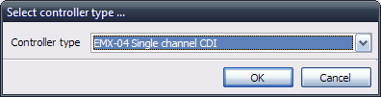
The next choice to make is to set which type of ECU that selected map file is associated with. Basically, select the ECU type relating to your own ECU.

When this is done, Infinity will open the selected map file and generate the worksheet for controlling the ECU.

Connecting to the ECU.

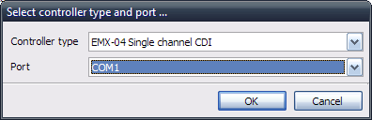
To connect Infinity to the ECU, make sure the RTD serial cable is connected between both the pc serial port and the ECU and make sure that the ECU is powered.

Click on the ECU connect icon.
You will now need to select the ECU type and also the comms port that you are using.

Once this is done, click on OK. Infinity will now attempt to communicate with the ECU.
If communication is successful, the screen will show the worksheet for controlling the ECU and live data should also displayed. An error message will be shown if communications has failed.

Controlling the ECU.

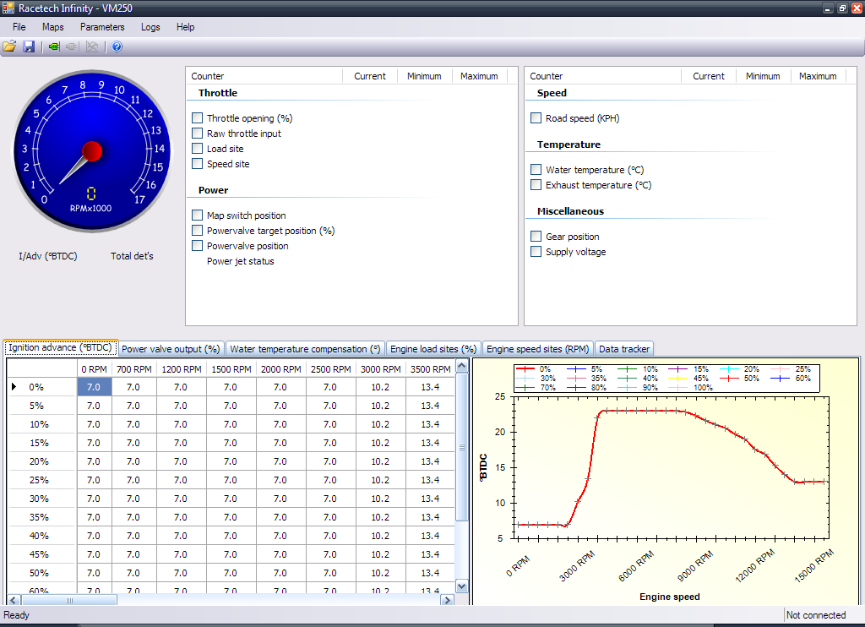
If you have connected to the ECU or are offline and have opened a map file from disk, you should see the main worksheet for controlling the ECU.
The worksheet is divided up intro three areas:

The top area is used to show live data from the ECU. The items displayed will vary between ECU types but in general it will show engine speed, road speed, load and speed sites, temperatures, gear positions and supply voltage. It will also show det counter totals and power jet and power valve status.

The bottom area is used for displaying the values held in each map/table. Tab headings for each of the accessible tables are shown above the table itself so you can easily select the table to view/edit. To the right-hand side is a graphical representation of the same data.

Click on a particular cell and type a new value or use the + and – keys to adjust the value in the cell. While the PC is connected to the ECU, changes made in the pc tables are also sent to the ECU.

Click on one of the labelled tabs to select a different table to edit.
Ignition map.

The values shown in this table are in degrees (BTDC) and represent the point during the crank revolution to ignite the fuel. The map is made up of a 16x32 value table. There are 16 engine load sites & 32 speed sites. Engine load is based on throttle position. There is interpolation between the speed and engine load sites giving gradual changes in ignition advance values.

The map values are displayed in a window that is 12x8 sites in dimension. By using the arrow keys the cursor can be moved around to enable the user to look at a particular part of the map. Listed above the window are the speed sites and their respective speed values (See Speed sites). To change one of the map values move the cursor to the required position and type in the new ignition value and then press ENTER to store the new value in the PC memory. Valid values in this map are between -49.9° and +70°.

Cylinder 2 ignition trim.

In EMX-05 ECUs, there is a second ignition table that allows for cylinder 2 to apply a different ignition advance from cylinder 1. This table is the same size as the normal ignition table. The range of values is -10° up to +10°.

Engine load sites.

The values in this map are in percentage of throttle opening. The valid range of values is 0 up to 100%. The a/d step value is the raw input from the sensor and is displayed next to the Throttle label in square brackets. There are two parameter values used to define the minimum and maximum throttle a/d step points. These two points are then used to derive the 0-100% throttle range.

Engine speed sites.

These values relate to the crank speed-readings from the engine. There are 32 speed sites. This map is used to define the 32 set points from which interpolated values may be calculated for other maps. Values of 0 up to 17000 rpm may be entered.

Water temperature compensation.

The Water temperature input on the ECU may be used to adjust the ignition timing for specific conditions. For example, an over heating engine can have the ignition timing retarded. The range of adjustment is +/-22°.

Power valve map.

This engine load vs. engine speed map allows the user to specify a required opening of the power valve. If all the load curves are set equally, or if the throttle input is switched off, the ECU will apply a target power valve opening based solely on engine speed. The run display will show the target power valve openings and the actually measure opening to allow the user to check for correct operation of the valve. Two parameters also allow the user to control the speed of the power valve. The near value is used for targets within 10% of required opening and the far value is for greater than 10% difference.

Data tracker.

This graph screen allows you to track specific live data channels while running the engine. Just select the particular live data channel to add it to the list of tracked channels. This feature only works if the PC is connected to the ECU.

Comments.
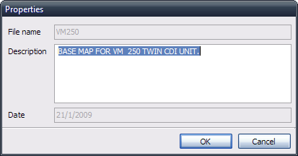
This function allows the user to view and edit comments stored in the ECU. Along with the comments a map name and an entry date for the comments will also be shown. You can enter up to 240 characters.

Parameters.

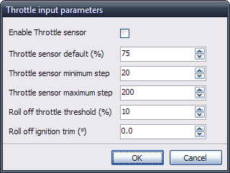
The parameters are individual values used for control settings where a map/table is not required. In each case edit the required value and press ENTER or click on OK.

Enable Throttle sensor: enables/disables the throttle sensor input. When disabled, throttle input is set at minimum and the throttle default value is not used.

Throttle sensor default(%): applied by the ECU if a short or open circuit condition is detected by the ECU.

Throttle sensor minimum step: a/d step value used to set 0% throttle opening point.
Throttle sensor maximum step: a/d step value used to set 100% throttle opening point.

Roll off throttle threshold(%): sets a level of throttle below which generates a Roll-off status in the ECU. This used to apply a retard to the ignition when the throttle is closed and overrides any trim required for the current gear position.

Roll off ignition trim(°): sets the ignition trim value needed for roll-off.

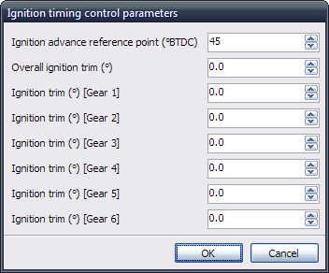
Ignition advance reference point(°BTDC): used to set a reference point for the ECU to time ignition advance from. At speeds of 700 rpm and above, the ECU will time from this point until the required ignition advance point is reached. Below 700 rpm, a mechanical method is used to trigger the spark, on the back edge of a slug or a specific tooth that is at the desired cranking advance.

Ignition trim(°) [Gears 1-6]: each value sets an ignition trim value for that specific gear position.

Overall ignition trim(°): this is a global trim function that allows the user to advance or retard the ignition output without altering the map values. This is an alternative method to physically moving the pick-up position. An allowable range of movement is +/- 22°.

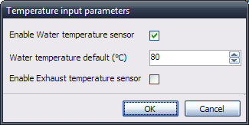
Enable Water temperature sensor: enables/disables the water temperature input. When disabled, the water temperature default value is not used and no water temp compensation is applied.

Water temperature default(°C): applied by the ECU if a short or open circuit condition is detected by the ECU.

Enable Exhaust temperature sensor: enables/disables the exhaust temperature input. This input is only intended for logging exhaust temperatures. No specific function is associated with it in the control of the engine.

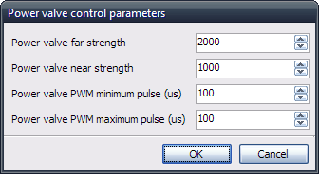
Power valve far strength: used to control the speed of movement in the power valve for large differences (>= 10%) in target and actual power valve opening.

Power valve near strength: used to control the speed of movement in the power valve for small differences (< 10%) in target and actual power valve opening. Too small a value will make the power valve sluggish in operation but too fast will cause overshooting or ‘chatter’ in the valve control.

Power valve PWM minimum pulse(us): used with power valve motors with no feedback signal.
Power valve PWM maximum pulse(us): used with power valve motors with no feedback signal.

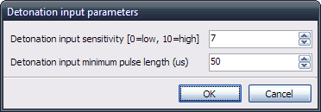
Detonation input sensitivity: used to set input sensitivity level for the detonation sensor. EMX-04 ECUs have two levels, 0=low & 1=high while EMX-05 ECUs have 11 levels with 0=lowest and 10=highest.

Detonation input minimum pulse length(us): sets a minimum pulse length for the detonation input signal. Pulses shorter than the threshold length are ignored by the ECU.

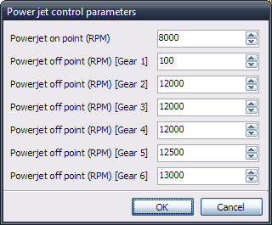
Power jet on point(rpm) = sets the engine speed point where the power jet may be switched on.

Power jet off point(rpm) [Gears 1-6] = sets the off point for the power jet depending on the current gear position. Neutral gear also uses the Gear 1 setting. Set the off point to 0 rpm to disable the power jet in a specific gear.
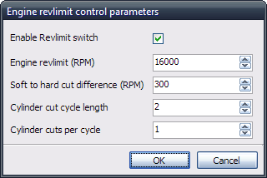
Enable Revlimit switch = enables/disables the cutting of sparks for excessively high engine revs.

Engine revlimit(rpm) = sets the engine speed where cutting of sparks will commence. Soft cutting of sparks is applied while engine speed is greater than the revlimit value but below revlimit + soft to hard cut difference. Hard cutting of sparks is applied when engine revs exceed the revlimit + soft to hard cut difference.

Soft to hard cut difference(rpm) = sets the band of engine revs above the revlimit threshold where soft cutting of sparks may be used. Set to zero if only hard cutting is required.

Cylinder cut cycle length = used in setting strength of the soft cut. Normally set to 1.
Cylinders cut per cycle = used in setting strength of the soft cut. Normally set to 2.

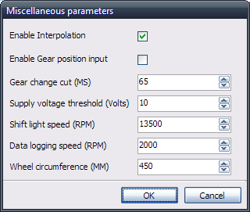
Enable Interpolation = enables/disables interpolation of map values between the set points of engine speed and engine load (throttle). When disabled, the map values will switch between the defined locations in a coarse operation. Enabling interpolation allows a much smoother progression between set points in maps.

Enable Gear position input = enables/disables the gear position sensor input. Used to tell the ECU which gear is currently selected.

Gear change cut(ms) = sets the period of ignition cutting initiated by the gear cut input being linked to 0V/earth/ground via a button or quick shifter. This cutting period is followed by a fixed null period where normal firings are applied. This is set at 1 second. No further cuts can be applied until the null period has elapsed.

Supply voltage threshold(volts) = sets a supply voltage threshold where ignition output is disabled. This would normally be set to 9 volts.

Shift light speed(rpm) = sets the engine speed where the shift light output is activated.
Data logging speed(rpm) = sets the engine speed where the internal data logging is activated.

Wheel circumference(mm) = used to calibrate the road speed input. Defines the distance around the measured wheel between road speed measuring points. These points would be a single tooth or maybe a pair of teeth positioned equidistantly on the wheel.

